DAY 9 - C/C++ PROGRAMMING - HARSHINIE M

/*
Purpose : Program to demonstrate runtime polymorphism using virtual functions
and the importance of virtual destructor.
Author : Harshinie M
Date : 02-01-2026
*/

#include <iostream>
using namespace std;

class Base{
public:
Base(){
cout << "Base::Base() --> ctor" << endl;}
virtual ~Base(){
cout << "Base::~Base() --> dtor" << endl;}
virtual void funone(){
cout << "Base::funone()" << endl;}
virtual void funtwo(){
cout << "Base::funtwo()" << endl;}
};
class Derived:public Base{
public:
Derived(){
cout<<"Derived::Derived() --> ctor"<<endl;}
~Derived(){
cout<<"Derived::~Derived()--> dtor"<<endl;}
void funOne(){
cout<<"Derived::funOne()"<<endl;}
void funTwo(){
cout<<"Derived::funTwo()"<<endl;}
};
int main(){
Base *bPtr = new Base();
bPtr -> funone();
bPtr -> funtwo();
delete bPtr;
cout << "*************************************************\n";
bPtr = new Derived();
bPtr->funone();
bPtr->funtwo();
delete bPtr;
}
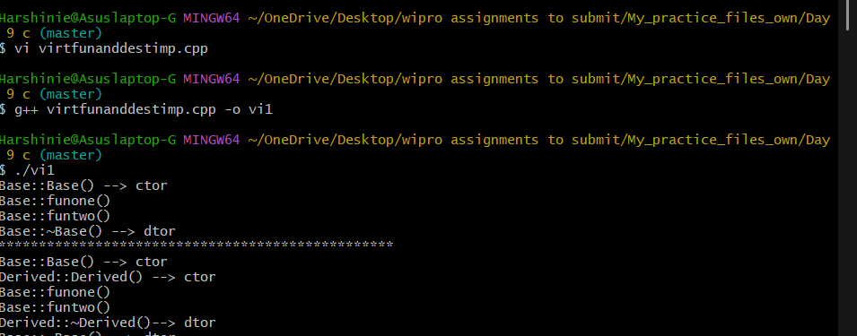

/*
Purpose : Program to demonstrate runtime polymorphism using virtual functions
and the importance of virtual destructor when deleting objects
through a base class pointer passed to a function.
Author : Harshinie M
Date : 02-01-2026
*/

#include <iostream>
using namespace std;

class Base {
public:
Base() {
cout << "Base::Base() --> ctor" << endl;
}

virtual ~Base() {
cout << "Base::~Base()--> dtor" << endl;
}

virtual void funOne() {
cout << "Base::funOne()" << endl;
}

virtual void funTwo() {
cout << "Base::funTwo()" << endl;
}
};

class Derived : public Base {
public:
Derived() {
cout << "Derived::Derived() --> ctor" << endl;
}

~Derived() {
cout << "Derived::~Derived()--> dtor" << endl;
}

void funOne() {
cout << "Derived::funOne()" << endl;
}

void funTwo() {
cout << "Derived::funTwo()" << endl;
}
};

void funCaller(Base *bptr) {
bptr->funOne();
bptr->funTwo();
delete bptr;
cout << "*********************************************\n";
}

int main() {
funCaller(new Base());
funCaller(new Derived());
return 0;
}

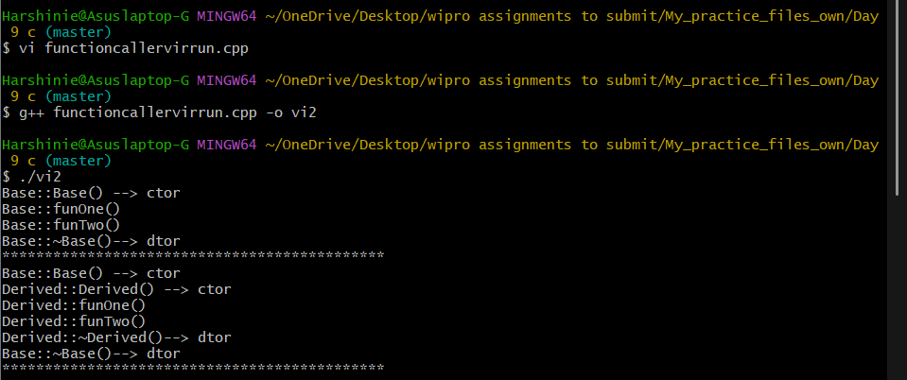

/*
Purpose : Program to demonstrate a Student Management System using
inheritance, virtual functions, dynamic object creation,
and runtime polymorphism.
Author : Harshinie M
Date : 02-01-2026
*/

#include <iostream>
#include <string>
using namespace std;

class Student {
protected:
string name;
int rollNo;

public:
Student(string n, int r) : name(n), rollNo(r) {}

virtual void calculateGrade() {
cout << "Base Student grade calculation" << endl;
}

virtual ~Student() {}
};

class Undergraduate : public Student {
int marks;

public:
Undergraduate(string n, int r, int m)
: Student(n, r), marks(m) {}

void calculateGrade() {
cout << "Undergraduate Student\n";
cout << "Name: " << name << ", Roll No: " << rollNo << endl;

if (marks >= 50)
cout << "Final Grade: PASS\n";
else
cout << "Final Grade: FAIL\n";
}
};

class Postgraduate : public Student {
int marks;

public:
Postgraduate(string n, int r, int m)
: Student(n, r), marks(m) {}

void calculateGrade() {
cout << "Postgraduate Student\n";
cout << "Name: " << name << ", Roll No: " << rollNo << endl;

if (marks >= 60)
cout << "Final Grade: PASS\n";
else
cout << "Final Grade: FAIL\n";
}
};

class ResearchStudent : public Student {
int publications;

public:
ResearchStudent(string n, int r, int p)
: Student(n, r), publications(p) {}

void calculateGrade() {
cout << "Research Student\n";
cout << "Name: " << name << ", Roll No: " << rollNo << endl;

if (publications >= 2)
cout << "Final Grade: PASS\n";
else
cout << "Final Grade: FAIL\n";
}
};

int main() {
Student *sPtr;
int choice;

cout << "1. Undergraduate\n2. Postgraduate\n3. Research Student\n";
cout << "Enter student type: ";
cin >> choice;

string name;
int roll;

cout << "Enter name: ";
cin >> name;
cout << "Enter roll number: ";
cin >> roll;

if (choice == 1) {
int marks;
cout << "Enter marks: ";
cin >> marks;
sPtr = new Undergraduate(name, roll, marks);
}
else if (choice == 2) {
int marks;
cout << "Enter marks: ";
cin >> marks;
sPtr = new Postgraduate(name, roll, marks);
}
else if (choice == 3) {
int pubs;
cout << "Enter number of publications: ";
cin >> pubs;
sPtr = new ResearchStudent(name, roll, pubs);
}
else {
cout << "Invalid choice\n";
return 0;
}

cout << "\n--- Grade Evaluation ---\n";
sPtr->calculateGrade();

delete sPtr;
return 0;
}
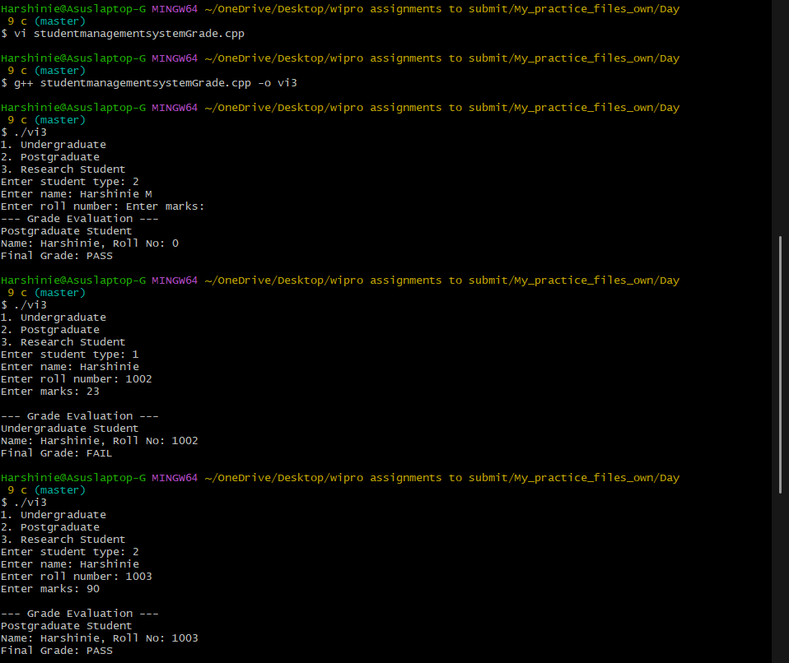

/*
Purpose : Program to demonstrate an Employee Payroll System using inheritance,
virtual functions, dynamic object creation, and runtime polymorphism.
Author : Harshinie M
Date : 02-01-2026
*/

#include <iostream>
#include <string>
using namespace std;

class Employee {
protected:
string name;
int id;

public:
Employee(string n, int i) : name(n), id(i) {}

virtual void calculateSalary() {
cout << "Base Employee salary calculation" << endl;
}

virtual ~Employee() {}
};

class FullTimeEmployee : public Employee {
double basicPay;
double allowances;

public:
FullTimeEmployee(string n, int i, double b, double a)
: Employee(n, i), basicPay(b), allowances(a) {}

void calculateSalary() {
double salary = basicPay + allowances;
cout << "Full-Time Employee\n";
cout << "ID: " << id << ", Name: " << name << endl;
cout << "Salary: " << salary << endl;
}
};

class PartTimeEmployee : public Employee {
double hoursWorked;
double payPerHour;

public:
PartTimeEmployee(string n, int i, double h, double p)
: Employee(n, i), hoursWorked(h), payPerHour(p) {}

void calculateSalary() {
double salary = hoursWorked * payPerHour;
cout << "Part-Time Employee\n";
cout << "ID: " << id << ", Name: " << name << endl;
cout << "Salary: " << salary << endl;
}
};

class ContractEmployee : public Employee {
double contractAmount;

public:
ContractEmployee(string n, int i, double c)
: Employee(n, i), contractAmount(c) {}

void calculateSalary() {
cout << "Contract Employee\n";
cout << "ID: " << id << ", Name: " << name << endl;
cout << "Salary: " << contractAmount << endl;
}
};

int main() {
Employee *ePtr;
int choice;

cout << "1. Full-Time Employee\n2. Part-Time Employee\n3. Contract Employee\n";
cout << "Enter employee type: ";
cin >> choice;

string name;
int id;
cout << "Enter name: ";
cin >> name;
cout << "Enter ID: ";
cin >> id;

if (choice == 1) {
double basic, allowances;
cout << "Enter basic pay: ";
cin >> basic;
cout << "Enter allowances: ";
cin >> allowances;
ePtr = new FullTimeEmployee(name, id, basic, allowances);
}
else if (choice == 2) {
double hours, rate;
cout << "Enter hours worked: ";
cin >> hours;
cout << "Enter pay per hour: ";
cin >> rate;
ePtr = new PartTimeEmployee(name, id, hours, rate);
}
else if (choice == 3) {
double amount;
cout << "Enter contract amount: ";
cin >> amount;
ePtr = new ContractEmployee(name, id, amount);
}
else {
cout << "Invalid choice\n";
return 0;
}

cout << "\n--- Salary Calculation ---\n";
ePtr->calculateSalary();

delete ePtr;
return 0;
}

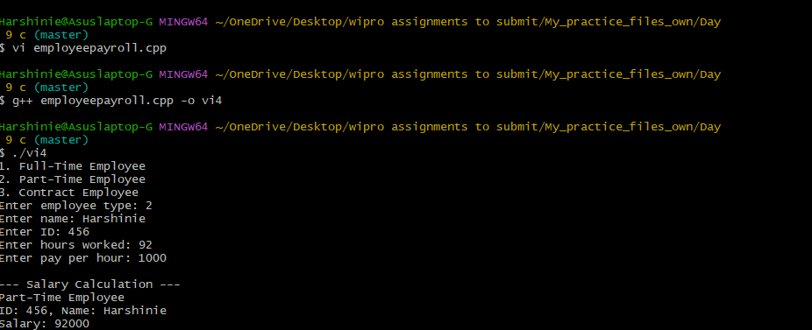

/*
Purpose : Program to demonstrate runtime polymorphism using inheritance
by checking attendance eligibility of different students.
Author : Harshinie M
Date : 02-01-2026
*/

#include <iostream>
#include <string>
using namespace std;

class StdAttendance {
protected:
string name;
int attendance;

public:
StdAttendance(string n, int a) : name(n), attendance(a) {}

string getName() {
return name;
}

virtual bool checkEligibility() = 0;
virtual ~StdAttendance() {}
};

class ArtsStudent : public StdAttendance {
public:
ArtsStudent(string n, int a) : StdAttendance(n, a) {}

bool checkEligibility() {
return attendance >= 65;
}
};

class ScienceStudent : public StdAttendance {
public:
ScienceStudent(string n, int a) : StdAttendance(n, a) {}

bool checkEligibility() {
return attendance >= 70;
}
};

class EngineeringStudent : public StdAttendance {
public:
EngineeringStudent(string n, int a) : StdAttendance(n, a) {}

bool checkEligibility() {
return attendance >= 75;
}
};

int main() {

StdAttendance *sArr[] = {
new ArtsStudent("Smitha", 68),
new ScienceStudent("Rahul", 72),
new EngineeringStudent("Sachin", 78),
new ArtsStudent("Balu", 64),
new ScienceStudent("Sharma", 72),
new EngineeringStudent("Rathore", 79),
NULL
};

for (int cnt = 0; sArr[cnt] != NULL; cnt++) {
cout << sArr[cnt]->getName() << " is ";
if (sArr[cnt]->checkEligibility())
cout << "Eligible" << endl;
else
cout << "Not Eligible" << endl;
}

for (int cnt = 0; sArr[cnt] != NULL; cnt++) {
delete sArr[cnt];
}

return 0;
}

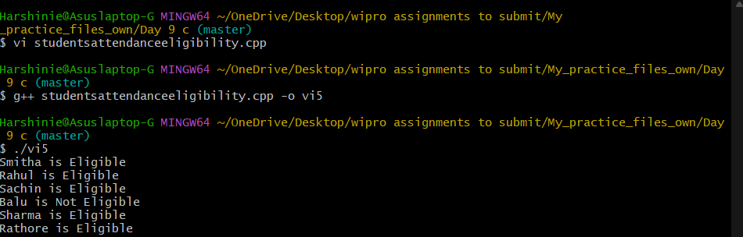

/*
Purpose : Program to demonstrate an Array Operations System using inheritance,
virtual functions, and runtime polymorphism to handle different
data types (int, float, string).
Author : Harshinie M
Date : 02-01-2026
*/

#include <iostream>
#include <string>
using namespace std;

class ArrayBase {
public:
virtual void insert() = 0; // pure virtual function
virtual void display() = 0; // pure virtual function
virtual ~ArrayBase() {}
};

class IntegerArray : public ArrayBase {
int arr[10];
int n;

public:
void insert() {
cout << "Enter number of integers: ";
cin >> n;
for (int i = 0; i < n; i++) {
cin >> arr[i];
}
}

void display() {
cout << "Integer Array: ";
for (int i = 0; i < n; i++) {
cout << arr[i] << " ";
}
cout << endl;
}
};

class FloatArray : public ArrayBase {
float arr[10];
int n;

public:
void insert() {
cout << "Enter number of floats: ";
cin >> n;
for (int i = 0; i < n; i++) {
cin >> arr[i];
}
}

void display() {
cout << "Float Array: ";
for (int i = 0; i < n; i++) {
cout << arr[i] << " ";
}
cout << endl;
}
};

class StringArray : public ArrayBase {
string arr[10];
int n;

public:
void insert() {
cout << "Enter number of strings: ";
cin >> n;
for (int i = 0; i < n; i++) {
cin >> arr[i];
}
}

void display() {
cout << "String Array: ";
for (int i = 0; i < n; i++) {
cout << arr[i] << " ";
}
cout << endl;
}
};

int main() {
ArrayBase *aPtr;
int choice;

cout << "1. Integer Array\n2. Float Array\n3. String Array\n";
cout << "Enter array type: ";
cin >> choice;

if (choice == 1) {
aPtr = new IntegerArray();
}
else if (choice == 2) {
aPtr = new FloatArray();
}
else if (choice == 3) {
aPtr = new StringArray();
}
else {
cout << "Invalid choice\n";
return 0;
}

aPtr->insert();
aPtr->display();

delete aPtr;
return 0;
}

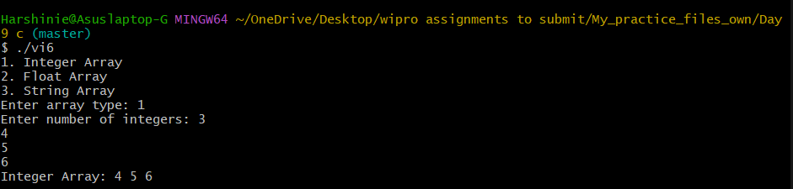

/*
Purpose : Program to demonstrate function calls with different
numbers of arguments in C.
Author : Harshinie M
Date : 02-01-2026
*/

#include <stdio.h>

void fun();
void funOne(int);
void funTwo(int, int);
void funThree(int, int, int);
void funFour();

int main(){
fun();
funOne(10);
funTwo(100,200);
funThree(11, 22, 33);
funFour();
return 0;
}

void fun(){
printf("void fun() called...\n");
}

void funOne(int x){
printf("void funOne(%d) called...\n", x);
}

void funTwo(int x, int y){
printf("void funTwo(%d, %d) called...\n", x, y);
}

void funThree(int x, int y, int z){
printf("void funThree(%d, %d, %d) called...\n", x, y, z);
}

void funFour(){
printf("void funFour() called...\n");
}

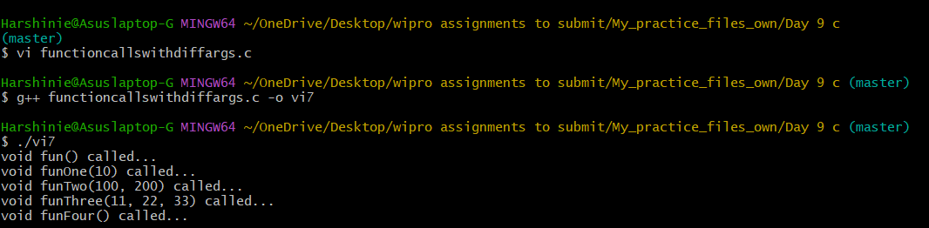
/*
Purpose : Program to demonstrate use of header files and
separate compilation in C.
Author : Harshinie M
Date : 02-01-2026
*/

vi funDecl.h
#include <stdio.h>
void fun();
void funOne(int);
void funTwo(int, int);
void funThree(int, int, int);
void funFour();
vi fundefi.c
#include "funDecl.h"
void fun(){
printf("void fun() called...\n");
}
void funOne(int x){
printf("void funOne(%d) called...\n", x);
}
void funTwo(int x, int y){
printf("void funTwo(%d, %d) called...\n", x, y);
}
void funThree(int x, int y, int z){
printf("void funThree(%d, %d, %d) called...\n", x, y, z);
}
void funFour(){
printf("void funFour() called...\n");
}
vi funmain.c
#include "funDecl.h"
int main(){
fun();
funOne(10);
funTwo(100,200);
funThree(11, 22, 33);
funFour();
}
gcc -c fundefi.c
gcc -c funmain.c
gcc fundefi.c funmain.c -o fun
./fun
